
The Charter a Group
Tel: +44 (0)1737 823733

2005 Robinson R44

Sale Price- €180,000
Ref: CH85120

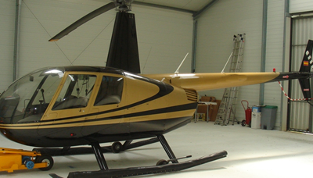
Year: 2005
Hours: 178
Standard plus
- Artificial horizon
- Pop-up floats
- Astra paint scheme

Interior brown leather

