
The Charter a Group
Tel: +44 (0)1737 823733

2010 A109S

Sale Price- $6.45 million
Ref: CH11038

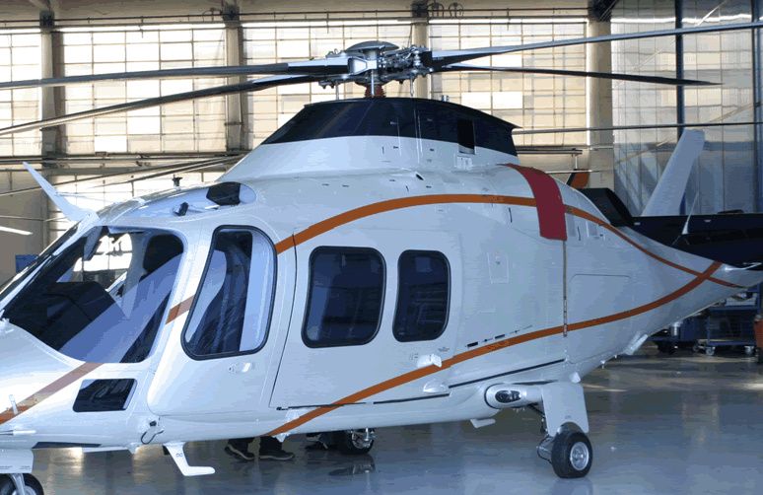
- VIP cabin passengers
- Sliding doors
- P&W207C engines
- Air conditioning ECU Garret
- Passive vibration absorber
- Structural provision for utility equipment (emergency floats, rescue hoist, cargo hook, weather radar, engine fire extinguisher, flight director, AFCS)

STANDARD EQUIPMENT:
- Pilot and copilot headsets
- Pilot and co-pilot shoulders harness with inertia reel
- Baggage compartment light
- Crew open doors actuators
- Quick disconnecting chip detectors
- Portable fire extinguisher
- Fuel drain vertical valves
- Tail boom strake
- First aid kit
- Airframe hour meter

ADDITIONAL EQUIPMENT:
- Dual control
- Rotor Brake
- Retractable/rotating 450W landing light
- Pilot and co-pilot windshield wipers with wiper switch on cyclic grip
- Engine compartment fire extinguishers
- Baggage compartment extension (to 1.9 m)
- Wire strike Protection System
- Emergency Floats provision
- Emergency floats removable
- Mass Vibration absorber

AVIONIC:
- LCD EADI and EHSI
- Stand-by ADI
- Barometric altimeter
- Airspeed indicator
- VSI
- EFIS pilot/co-pilot in command switch
- Honeywell FZ702 Flight Director with autotrim
- Honeywell AA300 Radio altimeter
- Honeywell C14 Gyrocompass
- Flightline System 46060-11 Vertical Gyro
- JET Electronics VG-208 Vertical Gyro
- Honeywell SP711 3-axis duplex AFCS
- Bendix/King KR-87 ADF
- Bendix/King KT-73 Transponder (mode S)
- Garmin GNS530 VHF COM/NAV/GPS
- Garmin GNS430 VHF COM/NAV/GPS
- Bendix/King KDM706A DME
- Bendix/King KMR675 Marker beacon
- Artex C406-2HM ELT
- Bendix/King KMD550 Moving Map
- Radio master switch with ground function
- Pilot ICS (including pilot/co-pilot control panel, mode controller, audio cabin control)
- AC power supply system (two inverters)

