Agusta 109E Power Elite
Price: $2.5m USD
Aircraft Specification
Year: 2002
Total Airframe Hours: 1986hrs (est)
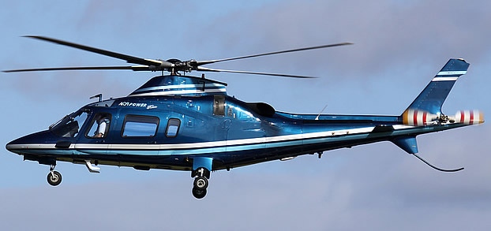
Description
Single Pilot IFR / Executive with Five Place Cabin plus Two Crew
Specifications/Performances
Engine Type: Two (2) Pratt & Whitney 206C with FADEC
Engine Times: (#1) 686 Hours / 1455 Cycles, (#2) 719 Hours / 1531 Cycles
Avionics
All standard A-109E Single Pilot IFR items plus the following features
EGPWS-CAA Certified Honeywell Installed by Agusta
AFCS 3 Axis Duplex Honeywell SP 711
Flight Director & Auto Trim Honeywell FZ 702
Flight Management System UNS 1L with Data Loader
Dual EHSI KRATUS
Dual ADI Honeywell
Dual VHF Nav / Comm King KX 165
Weather Radar King/Bendix RDR 2000
GPS Garmin 165
Moving Map #1 Avedyne-Orbcom WX MFD EX500 (GPS, Rdar, Strm Sc)
Moving Map #2 Argus 5000 CETransponder
Garmin 330DME
Collins DME-42
ADF King KR 87
Storm Scope B.F. Goodrich 5000
Radio Altimeter ALT AA300
ELT EBC 302H
Compass System Honeywell C 14
TCAS B.F. Goodrich 497
Sat Phone Aircell ST3100

Other Equipment and Features
Dual Controls
Rotor Brake
AC System w/ 2 Inverters
27 Amp Hour Battery
Windshield Wipers (2)
Eng. Compt. Fire Extinguisher
Air Conditioning
Garret ECU True Airspeed System
230 US Gal. Fuel System
Retractable Landing Light
Recognition and Strobe Pulsed Chip Detectors
Dual electric passenger steps
Passenger and crew Gemelli intercom system
Bose active noise canceling headsets
Passenger sliding doors

Exterior - Sky Blue with green bottom and white stripes
Interior - Agusta factory installed interior items include: “VIP” corporate interior with leather seating in five (5) place cabin with refreshment console and two (2) place leather crew seating in flight deck area.

