1992 MCDONNELL DOUGLAS MD520N

Sale Price £420,000

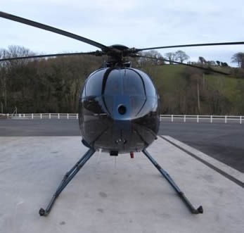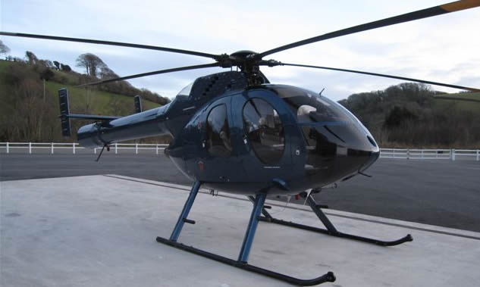

• Aircraft Total Hours: 1385 • No Damage History
• Allison 250-C20RS Engine • Available now
• All AD’s & SB’s Current • Fresh FAA Annual Insp Jan 09
• Always Hangared • Located UK
• Empty Weight 1926 Pounds • Extex First Stage Engine Nozzel

♦ INSTALLED ACCESSORIES ♦

- Extended (High) Skid Landing Gear - Pitot Heat
- Crew & Passenger Steps - Yaw SAS
- Rotor Brake - Particle Separator
- Dual Controls - Aeronautical Accessory Rain Gutters
- Aero Air Freon Air Conditioning - Fargo 21 Gal. Aux. Fuel Tank
- Cabin Heater - Cargo Hook Provisions Only
- Par Avion Pneumatic Door Openers - External Cargo Mirror
- Strobe Lights - Gill Lead Acid Battery
- Digital OAT Gauge
- Facet Engine Oil Filter - Rotor Tie Downs/Inlet Covers

♦ INSTALLED AVIONICS ♦

- King KX-155 VHF Nav/Com - King KMA-24H Audio Panel
- Trimble TNL-3000 GPS Nav - King KT-70 Mode S Digital Transponder
- King KI-208 Omni Indicator - King KEA-127 Encoding Altimeter (Mode C)
- Davtron M-655 Five Function Indicator - 4 Place Voice Activated Intercom
- Pointer 3000-10 ELT - 4 Headsets
- NEC M3800 Cellular Telephone - NAT AA34-00 Radio Interface Unit

♦ COSMETICS ♦

EXTERIOR: All Over Metallic Blue
(Excellent Condition)

INTERIOR: Custom Aircraft Interior in All Blue Leather and with Soundproofing
(Excellent Condition)

♦ COMMENTS ♦

-1x new & 4x reconditioned blades
- Specification subject to verification at inspection.

